CSCI 1470 – Fall 2015
Lab 5 In-class Assignment

Topic: Static Graphics and Images
Submit all source codes (*.cpp) at the same time via email to clarenceb@uca.edu and to tvalesco1@cub.uca.edu

*Note: Include the following set of comments at the top of your source code for all assignments.

// Student Name:
// Assignment #: (Example: A5-1)
// Lab Time: Tuesday 2:40-4:30
/**************************Title of Program**********************************
Author: Date of Work:

Design: Provide an general overall description of the program

Input:

Process:

Output:

***************************************************************************/

1. Download “italy.bmp” from http://faculty.uca.edu/clarenceb

2. Use the UCA graphics files “graph1.h” and “graphLib2010.lib”.

2. (Save this file as A5-1.cpp.) Write a C++ program that will displays a flag and map for a given country in the Graphics Window. We’ll only display a flag that was created from colored rectangular regions. For instance, the Italian flag is created from 3 colored regions (green/white/red).

Italian Flag
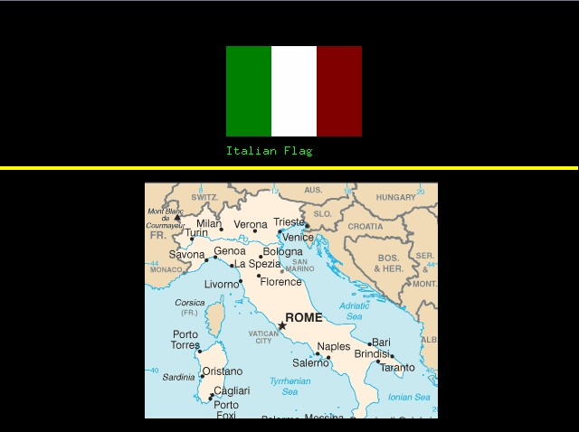
The caption (Italian Flag) is to be place beneath the flag. A yellow line will also separate the flag from the map. The following example illustrates how the Italian flag/map is placed in the Graphics Window:
50

100
100
Suggested dimensions are shown above. Use these additional requirements too:

- The upper left coordinate of the Italian flag is suggested as (250, 50).

- The captions should be placed 20 pixels beneath the flag aligned to the left edge of the flag.

- The horizontal yellow line should be placed approximately 15 pixels beneath the caption.

- The yellow line is across the page with 3 pixels wide

- The map should be displayed approximately 25 pixels beneath the yellow line.

- The upper left x coordinate of the Italian map is suggested to be 160 (we’ll compute the y coordinate based on the other object’s positions). The dimension of the map is 324x262 pixels.

CSCI 1470 – Fall 2015
Lab 5 Out-of-class Assignment
Due Date: Monday, 9/28/15 @ 11:00PM

Topic: Graphics
Submit all source codes (*.cpp) at the same time via email to clarenceb@uca.edu and to tvalesco1@cub.uca.edu

*Note: Please include appropriate comments at the top of the program

Assignments:
1. Download the file “moon.bmp” from http://faculty.uca.edu/clarenceb

2. (Save this file as B5-1.cpp.) Write a C++ program that displays the following night scene

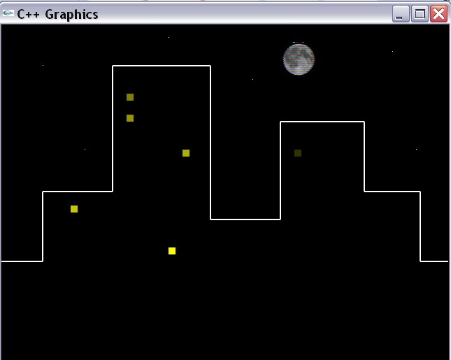
6
4
2
5
3
1
(359,79)
(593,179)
(559,39)
(239,19)
(119,179)
(59,59)
(400,25)
(639,339)
(599,339)
(399,139)
(599,239)
(519,239)
(519,139)
(399,279)
(299,279)
(299,59)
(159,59)
(159,239)
(59,239)
(59,339)
(0,339)

The coordinates for the endpoints of all lines are shown. The coordinates of each point (representing a star are also shown. The upper left coordinates for the moon are shown as well.

Each rectangle represents a window in the building and has a dimension of 10x10. The yellow color in each window represents a light. The coordinates (inserted between ()) and colors (inserted between <> in Red, Green, Blue order) for the rectangles are shown below (Blue needs to be 0, and R/G are equal to generate a shade of Yellow).

The rectangles are numbered from 1 thru 6. This rectangle number corresponds to a number in the screen capture above.
Rectangle 1: Coordinates: (179,99) Color <128,128,0>

Rectangle 2: Coordinates: (179,129) Color <150,150,0>

Rectangle 3: Coordinates: (259,179) Color <175,175,0>

Rectangle 4: Coordinates: (99,259) Color: <200,200,0>

Rectangle 5: Coordinates: (239,319) Color: <255,255,0>

Rectangle 6: Coordinates: (419,179) Color: <50,50,0>

Your completed program should display the following graphics window (same as previous illustration but coordinates not shown).
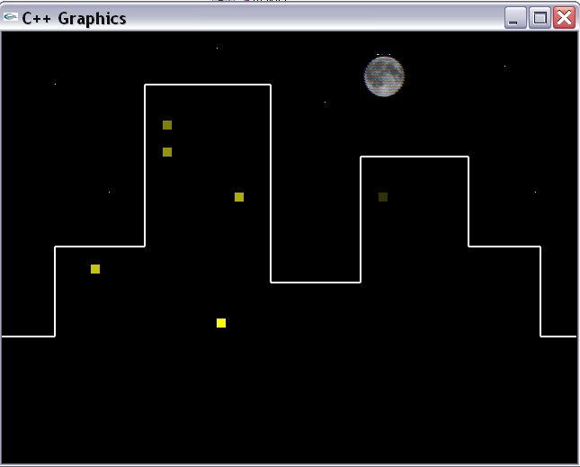
3. (Save this file as B5-2.cpp.) Write a C++ program that creates a night scene, similar to the scene for B4-1 that consists of the following:
(593,179)
(599,339)
(599,239)
(519,239)
(399,279)
(299,279)
(159,59)
(59,339)
- Use rectangles to create 6 different buildings with different shadings (i.e., with 6 different colors of grey).
- Display an image of the Moon above the buildings
- Use the lights in one of the buildings to make a design, such as Z or X, using the same size lights as used in B5-1.
- Make appropriate comments at the top of the program and throughout the program.
- Be creative with your work.

