AQUATIC HABITATS
classified by different criteria than terrestrial
depth—fig 3.6
--light only in upper surface of ocean
--nutrients fall to bottom of oceans/lakes
--photosynthesis limited due light and nutrients in different places
--where will photosynthesis be greatest in the ocean?

flow rate—fig 3.34
--streams are constantly disturbed by moving water
focus reading on oceans and running water—not lakes

Why are there so many species?
Organisms adapt to different conditions
Chap 4 and 5 are about the physiological adaptations of plants and animals to conditions (water and temperature).
Organism adapt to other organisms

Resources required for life:
1. water
2. energy:
plants--light animals--other organisms
3. nutrients, i.e. matter such as nitrogen, phosphorus, potassium, etc

Energy
What is energy?
Can't be created or destroyed, but does change forms.
Solar energy--electromagnetic rays; some of that energy strikes bare ground, rocks, etc. and is reradiated as heat, some is stored in chemical bonds thru photosynthesis;
energy stored in chemical bonds can be broken and the energy released to do work in the plant or in an animal that eats the plant or by some fungi or bacteria that consumes the dead body of the plant.
Eventually all the energy originally stored in chemical bonds thru photosynthesis is released as heat to the environment.

Plants and animals differ in energy acquisition

Critical resources for plants:
solar radiation—electromagnetic radiation
water
nutrients

Solar Radiation or Light
variable
globally
locally (north vs south slopes)
daily,--plants usually show mid-day depression--at least those around here
seasonally
interactions with neighbors (neighboring leaves of same plant as well as neighboring plants). (see Fig 6.3)
shade vs sun plants; adapted to different light levels

Water :
Major impacts on Ps rates--as important as light (chap 5)
Lack of water closes stomates
plants vary in adaptations to deal with water stress
Roots forage for resources in soil--only young roots pick up water, up to 60% of photosynthesis can go to roots (fig. 5.12)
competition occurs between neighboring plants--different species may be adapted to exploit soil differently

Nutrients:
matter
CO₂
required for Photosynthesis;
must open stomates
water is lost
not variable in space
vary in time--level increasing--expect to double by 2075
How this will impact plants?
different Photosynthetic pathways: C3; C4; CAM
change competition between C3 and C4

Other Nutrients
Nitrogen, Phosphorus, Potassium taken up with water in soil
How do nutrients impact Ps?
patchy in distribution; roots selectively develop in high nutrient patches
two things to remember about resources for plants:
very similar for all plants
Can't examine the resources above independently--they are linked
What happens when stomates open?--water is lost, so CO2 becomes more limited as water becomes limited.
Nitrogen: 75% of N in leaves is in photosynthetic enzymes and membranes--Nitrogen is the most commonly limiting nutrient in plants--High light is only a source of heat to plants with limited nutrient levels

ENERGY AQUISITION BY ANIMALS:

all energy in form of organic compounds originally produced thru photosynthesis

Organic molecules come packaged in different ways:
eat plants, animals, fungi
can eat them while living or dead (fig 6.12)
Nutritional content of plants and animals as food (fig 6.7)
 | Plants | Animals/ fungi
C/N | 40:1 | 8:1 10:1
 | largely undigestable cell walls | easy to digest fats & protein
 | grinding important to separate cell walls from cell contents
 | C/N high even without cell walls (aphids)

variablity | nutritional value highly variable | more homogeneous
within an individual (fig 6.9) :
High N--seeds, young leaves
high starch—storage tubers
high fiber--wood, old leaves, twigs
between species (6.10):
defensive chemicals

defense | plants can't run away | animals run
physical | spines (plant trichomes) | spines (porcupines)
 | hard shells(pecans) | hard shells (clams)
chemical | plant secondary metabolites
 | Terpenes: peppermint, pines

Foraging by plants and animals
Predict that if resources are limited, natural selection will favor individuals that are most effective at acquiring resources--foraging
Animal Foraging
optimal foraging
Optimal foraging can explain prey choice
Plant Foraging
foraging by animals involves behavioral choices, but in plants it is due to changing growth form and resource allocation in response to environmental cues.
Examples in text on plants adjusting ratio of roots to shoots (see Fig 6.25 & 6.26)

Resources and conditions define the niche of a species.
Niche: description of all the conditions and resources necessary for a species to survive and reproduce.
for example, for saguaro cactus, temperature is very important part of niche, but must add others: water--too little and it will die--too much and it may not be able to compete with something else.

Most accepted definition is Hutchinson (1957) n-dimensional hypervolume (defined on p. 328 )
think of temperatures influence on a plant--one dimension
add water--two dimensions
add pH of soil—three dimensions
Fundamental Niche is determined by physical conditions and resources
Realized Niche is influenced by biotic interactions
competition-interspecific
predation
Energy Flow in the whole ecosystem
Begin with plants and photosynthesis
photosynthesis of plants depends on solar radiation, water, and nutrients.
primary productivity is the rate at which biomass is produced per unit area by plants
expressed as dry matter, ie., kg/ha/year
gross PP (GPP) = total carbon fixed
net PP (NPP) = GPP - respiration by plants
Patterns of primary productivity:
(NPP global distribution) Fig 18.2

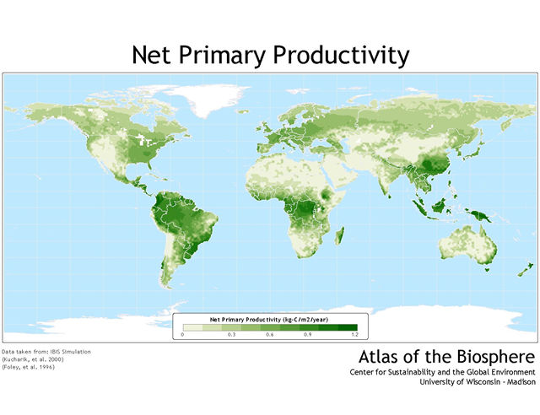
Factors limiting primary productivity:
terrestrial:
solar radiation
water (fig 18.3)
nutrients (fig 18.4, 18.5, 18.6, 18.7)

marine:
dependent on nutrients (fig 18.9)

Primary produces are eaten by consumers--two consequences:
Consumers can influence rate of primary productivity
top-down vs bottom-up controls on primary productivity
Secondary productivity is determined by primary productivity
why are big fierce animals rare?
limit to the number of trophic levels supported
positive correlation with NPP
secondary productivity an order of magnitude less than NPP: 100:10

where is the missing energy?

not all plant matter eaten > decomposers
some eaten & not digested > decomposers
lost as heat > respiration by animals

quantify above 3 categories:
consumption efficiency: how much NPP is eaten--
Assimilation efficiency: % of ingested food assimilated into body.
low for herbivores 20-50%
high for carnivores 80%
production efficiency: % assimilated energy that is turned into biomass
low endothermic organisms
higher for invertebrates and insects, snakes

MATTER or NUTRIENT CYCLING
Organic and inorganic pools of nutrients
inorganic pools
nitrogen in atmosphere
calcium, phosphorous in rocks
CO2 in air
organic pools
nutrients in living and dead organisms
nutrients in waste products
Nutrient inputs to communities or
How do communities gain nutrients?
transfer from inorganic to organic
Nitrogen fixation
N-fixing bacteria
lightning
minerals from weathered rock
photosynthesis increases C in organic pool
gain nutrients from another area or community
* runoff to streams and rivers can add nutrients to lowlands
decomposition—makes nutrients already in organic pool available for reuse by living organisms
what determines decomposition rate = what’s productivity of fungi and/or bacteria depend on?
Fig 19.7
Fig19.8

what biomes do you expect decomposition to occur rapidly in?
Fig 19.9
Nutrient losses from communities:
Return from organic to inorganic pool
* fires can volitilize CO2 and N2 (organic to inorganic)
* denitrifing bacteria release N to atmosphere
runoff can remove nutrients from slopes or leach from sandy soils

Nutrient cycling in temperate forests:
Hubbard Brook Experimental Forest
6 watersheds studied to get data on inputs and outputs
Main results:
inputs and outputs small compared to recycled nutrients and storage
damage to system increases output of nutrients
following deforestation of one watershed
dissolved nutrient in water increased 13 times
water flow increased 40% due to decreased transpiration
algal blooms in streams

Nutrient cycling in aquatic systems:
little storage or recycling in aquatic systems
one-way flow
inputs: inflow from watershed
outputs: loss in stream flow and sedimentation

Nutrient cycling in tropical rainforests:
decomposition occurs faster due to high temps + moisture
little storage in soils (contrast to temperate forests)
potential for loss in runoff if forest is disturbed
in undisturbed forests mycorrihizae key to nutrient uptake by plants
agricultural potential is low

Human disturbance of nutrient cycles:
Nutrient cycling in agricultural systems:
increase outputs of nutrients from agroecosystems
harvest and ship out crop containing nutrients
erosion--averages 3 tons/year/acre
compensate by increasing inputs to agroecosystem
commercial fertilizer (may equal natural N-fixation)

growing nitrogen-fixing crops
adding manure
result:
increased nutrient levels in aquatic systems

what lands are best for agriculture?
storage of organic matter in soil (decomposition at intermediate level)
runoff not excessive (rainfall intermediate)
potential in tropics lower than in temperate grasslands
increased nitrogen inputs to whole earth
nitrogen from inorganic to organic pool has doubled in last 50 years
burning fossil fuels
agriculture
spread of nitrogen fixing plants
great impacts on aquatic systems
river systems
gulf coast and east coast
some invasive, exotic plants are nitrogen fixers
Hawaiian ecosytems impacted by Myrica (see fig 19.21, 19.22)
increased CO2 to whole earth
How can adding fertilizers to ecosystem be bad?

