CSCI 1470
University of Central Arkansas
Lab 1 In-class Assignment
Topic: Compiler (Visual Studio.NET), output (cout), data types, basic operators,
Reading: Ch. 2

*Note: Include the following set of comments at the top of your source code for all assignments.
//Author:
//Assignment # (Example: A1-1.cpp)
//Lab Time: Tuesday, 2:40-4:30
// Date of Work:
// Description: Brief description of the purpose of the program (Example: Calculates the area of a square.)

Assignment
- Save this file as A1-1.cpp
Write a C++ program that displays your name, street address, city-state-zip code on 3 different lines.

Example Output:

Joe Smith
1215 Main
Conway, AR 72032

Paste the following code portion into .Net 2008 and fill in the blanks provided:

//Author: Joe Smith (Replace with your name)
//Assignment: A1-1
//Lab Time: Tuesday, 2:40-4:30
//Date of Work:
//Description: Displays my name, address, city, state and zip code

#include <_______>
_________________

int _____()
{
cout << "____\n" << "___\n" << "______\n";

return 0;
}

Additional Exercise:
Modify your completed A1-1 program replacing \n with endl. Save this file as A1-1.cpp and submit this completed exercise (i.e., the one containing endl) via email to clarenceb@uca.edu.

- Save this file as A1-2.cpp
Write a C++ program that displays the number “1” using asterisks “*” as follows

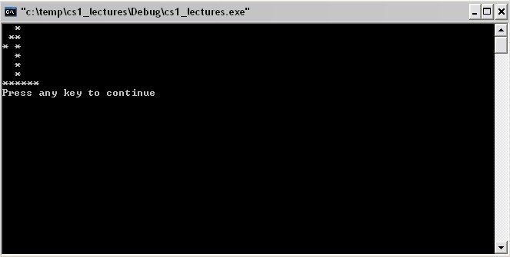

Submit A1-1.cpp and A1-2.cpp via email to clarenceb@uca.edu.

CSCI 1470
Lab 1 Out-of-class Assignment
Due: Monday, 8/31/2015 by 11:00 pm

Topics: Compiler (Visual Studio.NET), cout statements, newline, comments
Reading: Ch. 2

(The design header must be completed in order to earn any points for the lab.)
*Note: Include the following set of comments at the top of your source code for all assignments.

//Author: Your Name
//Assignment # (Example: B1-1)
//Lab Time: Tuesday, 2:40-4:30
//Date of Work:
//Description: Brief description of the purpose of the program (Example: Displays a pattern.)

Assignments:

- Save this file as B1-1.cpp. Write a program that displays the following information about you.

Name:
High School Attended:
Classification:

Sample output:

Name: Mary Smith
High School Attended: Vilonia
Classification: Freshman

Run your program and debug (fix or correct) if necessary

- Submit B1-1.cpp via email to clarenceb@uca.edu.

