CSCI 1470 – Fall 2015
Lab 4 In-class Assignment

Topic: Graphics
Reading: Ch. 4 /Supplement on Graphics
Submit all source codes (*.cpp) at the same time via email to clarenceb@uca.edu

*Note: Include the following set of comments at the top of your source code for all assignments.

// Student Name:
// Assignment #: (Example: A4-1)
// Lab Time: Tuesday 2:40-4:30
/**************************Title of Program**********************************
Author: Date of Work:

Design: Provide an general overall description of the program

Input:

Process:

Output:

***************************************************************************/

- Download “Lab4_Ex1.cpp”, “Lab4_Ex2.cpp” and “uca.bmp” from http://faculty.uca.edu/clarenceb

- (Save this file as A4-1.cpp) Write a program that processes information about lines. A line is defined by 2 points consisting of x/y coordinates:
Point 1
(x1,y1)

Point 2
(x2,y2)

Your program will perform the following steps:

1. Prompt the user for the x/y coordinates for Point 1 and Point 2. An example input of this step is shown below:

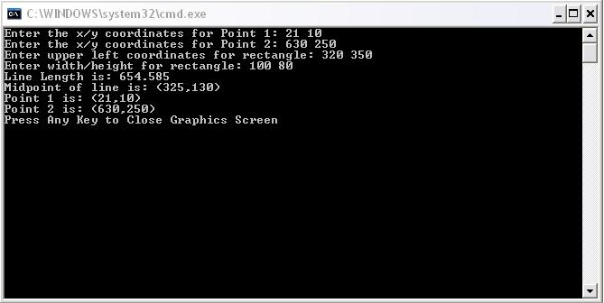

The x coordinate should be entered first followed by the y coordinate. Assume that the user will enter x-coordinate values between 0 and 639. Also assume the user will enter y-coordinates between 0 and 299.

2. Draw the line defined by these 2 points (use default color white). The width of the line is 1.

3. Compute the midpoint of the line. The equation for the midpoint coordinates is given as:

4. Compute the length of the line using the distance equation given below:

5. Draw a circle at each end point of the line. The radius of each circle is equal to 4.

6. Draw a circle at the midpoint of the line. The radius of this circle is equal to 4.

7. Draw a horizontal line whose purpose is to separate the line drawn above from the remaining section. This line is defined by the following 2 points: (0,300) and (639,300). The width of the line is 1.

- Draw a rectangle beneath the white horizontal line.
  - Prompt for inputting the upper left coordinate of rectangle
  - Prompt for inputting the width & height of a rectangle
  - Draw the rectangle. Make sure that the rectangle appears in the graphics window, i.e.: x-coordinate is within [0, 639-width], y-coordinate is within [301, 479-height]).

- Display the following information of the line drawn by steps 1 to 6: length, the midpoint, and the values for each point.

- The suggested coordinates for the first line is shown in the screen capture below. You can choose any coordinates that you like - make sure all lines and squares are shown in the graphics window.

An example output of your program is shown below:
(250,420)

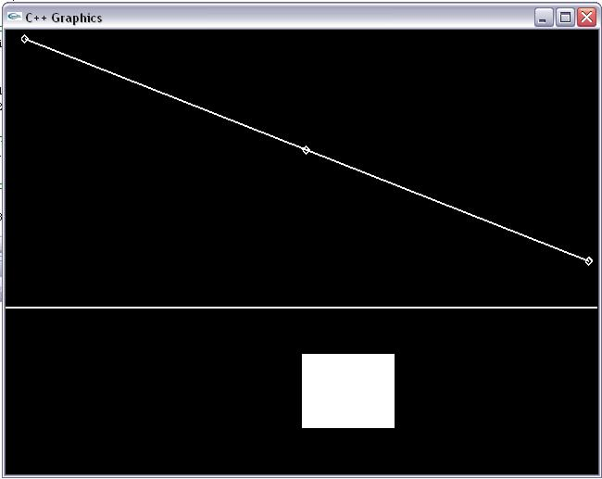
639,300
0, 300

CSCI 1470 – Fall 2015
Lab 4 Out-of-class Assignment
Due Date: Wednesday 09/23/15 @ 11:00PM

Topic: Graphics
Reading: Ch. 3 /Supplement on Graphics
Submit all source codes (*.cpp) at the same time via email to clarenceb@uca.edu

*Note: Please include appropriate comments at the top of the program
Assignments:
(Save this file as B4-1.cpp.) Write a program that processes information about lines.
Your program will perform the following steps:

    - Prompt the user for the x/y coordinates for Point 1 and Point 2. An example input of this step is shown below:
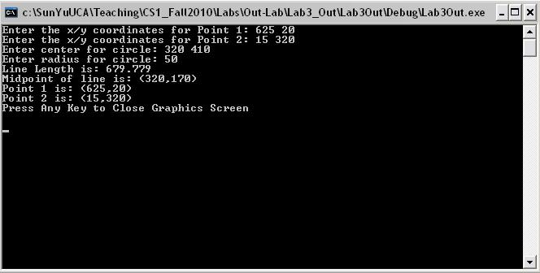

The x coordinate should be entered first followed by the y coordinate. Assume that the user will enter x-coordinate values between 0 and 639. Also assume the user will enter y-coordinates between 0 and 349.

2. Draw the line defined by these 2 points (use default color white).

3. Compute the midpoint of the line.

4. Compute the length of the line using the distance equation given below:

5. Draw a circle at each end point of the line. The radius of each circle is equal to 10.

6. Draw a circle at the midpoint of the line. The radius of this circle is equal to 10. The equation for the midpoint coordinates is given as:
7. Draw a horizontal line whose purpose is to separate the line drawn above from the remaining section. The endpoints of this line are (0,350) and (639,350).

8. Draw a circle beneath the white horizontal line.
  - Prompt for inputting the center of circle
  - Prompt for inputting the radius of circle
  - Draw the cricle. Make sure that the circle appears in the reaming graphics window which is below the horizontal line..

9. Display the following information of the line drawn by steps 1 to 6: length, the midpoint, and the values for each point.

10. The suggested coordinates for the line drawn by steps 1 to 6 are shown in the screen capture shown above. You can choose any coordinates that you like - make sure all lines and circles are shown in the graphics window.

An example output of your program is shown below:
