# Electron Groups on Central Atom | # Atoms bound to Central atom | # Lone Pairs | Type of Geometry | Shape | Molecular Depiction | Ideal Bond Angle | Hybridization on Central Atom | Example
2 | 2 | 0 | AB or AB₂ | Linear | 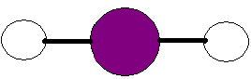 | 180 | sp | BeCl₂, CO₂
3 | 3 | 0 | AB₃ | Trigonal Planar | 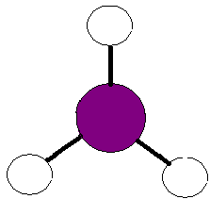 | 120 | sp² | BF₃, NO₃⁻
3 | 2 | 1 | AB₂N | Bent | 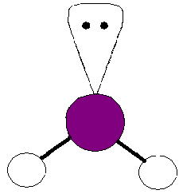 | <120 | sp² | SnCl₂, O₃

# Electron Groups on Central Atom | # Atoms bound to Central atom | # Lone Pairs | Type of Geometry | Shape | Molecular Depiction | Ideal Bond Angle | Hybridization on Central Atom | Example
4 | 4 | 0 | AB₄ | Tetrahedral | 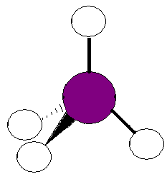 | 109.5 | sp³ | CH₄, CCl₂F₂
4 | 3 | 1 | AB₃N | Pyramidal | 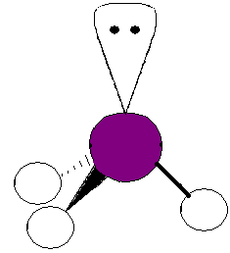 | <109.5 | sp³ | NH₃
4 | 2 | 2 | AB₂N₂ | Bent | 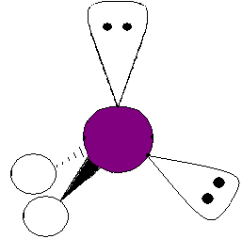 | <109.5 | sp³ | H₂O

# Electron Groups on Central Atom | # Atoms bound to Central atom | # Lone Pairs | Type of Geometry | Shape | Molecular Depiction | Ideal Bond Angle | Hybridization on Central Atom | Example
5 | 5 | 0 | AB₅ | Trigonal Bipyramidal | 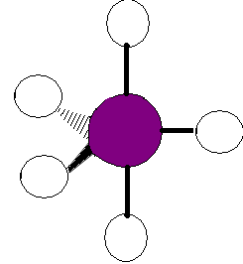 | 2 @ 90  3 @ 120 | sp³d | PCl₅
5 | 4 | 1 | AB₄N | See-Saw | 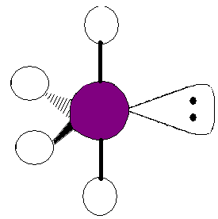 | 2@ <90  2@ <120 | sp³d | SF₄
5 | 3 | 2 | AB₃N₂ | T-shaped | 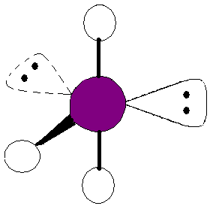 | 2@ <90  2@<120 | sp³d | BrF₃
# Electron Groups on Central Atom | # Atoms bound to Central atom | # Lone Pairs | Type of Geometry | Shape | Molecular Depiction | Ideal Bond Angle | Hybridization on Central Atom | Example
5 | 2 | 3 | AB₂N₃ | Linear | 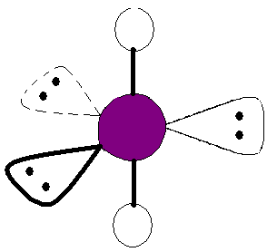 | 180 | sp³d | I₃⁻
6 | 6 | 0 | AB₆ | Octahedral | 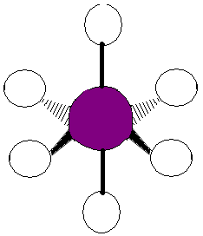 | 90 | sp³d² | SF₆
6 | 5 | 1 | AB₅N | Square Pyramidal | 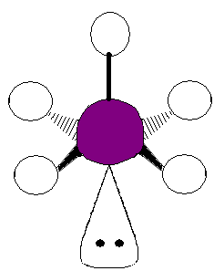 | <90 | sp³d² | IF₅

# Electron Groups on Central Atom | # Atoms bound to Central atom | # Lone Pairs | Type of Geometry | Shape | Molecular Depiction | Ideal Bond Angle | Hybridization on Central Atom | Example
6 | 4 | 2 | AB₄N₂ | Square Planar | 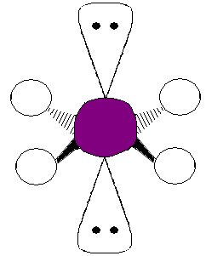 | 90 | sp³d² | XeF₄

Important Facts:

- VSEPR theory – valence shell electrons surrounding the central atom will repel each other so that they are as far apart as possible. The basic geometry is therefore determined by the # of electron groups surrounding the central atom.
- # Electron Groups on a Central Atom are determined as:
Lone pair = 1 group
Single Bond = 1 group
Double Bond = 1 group
Triple Bond = 1 group
- The shape of the molecule describes only bonding groups.
- The ideal bond angle listed is only valid if all atoms and bond types surrounding the central atom are the same.
- Spatial requirements: lone pair > bonding group, triple bond > double bond > single bond

