Humans have low r but steady population growth.
Insert fig 11.27 and 11.28
What is human carrying capacity?
What does it depend on (chap 11, question 10)
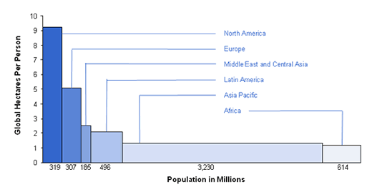

Depends on (1) resource use (2) population growth

INTERSPECIFIC COMPETITION

Examples of strong competition:

Gause's paramecium experiments--

sigmoid growth curves for P. aurelia and P. caudatum by themselves (Fig 13.15), but together P. aurelia out competed P. caudatum.
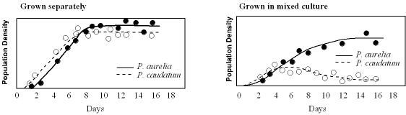

P. caudatum and P. bursaria coexisted together, but close examination revealed that P.caudatum feed on bacteria suspended in medium, and P. bursaria lived on yeast that fell to bottom of the tubes.

These results led to Gause's principle or the competitive exclusion principle:
two species cannot occupy the same niche
if two species coexist in the same habitat, it is because of niche differentiation, (realized niche)

At the same time Gause was working with Paramecium, mathematician produced models of competition based on population growth--these solidified the exclusion principle as they predicted the outcome: unless competitive abilities exactly equal for the two species, the weaker one was always eliminated over time

Barnacles
Connell (1961) studied two species of barnacles: Chthamalus and Balanus (Cham-a-lus and Ball-a-nus)
ECO--sp2003_files\balanus.ppt (and Fig 13.21)
live on same rocky shores, but
Chthamalus occurs higher up on shore than Balanus.
Chthamalus larvae settle in both zones, but survival is low in the presence of Balanus
if Chthamalus larvae are protected from Balanus, their survival is high, ie., it was not the physical conditions of lower shore that was killing Chthamalus larvae
Balanus was limited to lower shore due to its sensitivity to desiccation--not competition

You can see niche here. The fundamental niche (defined by physical environment) of Chthamalus included both the higher and lower intertidal area, however the reaized niche (due to interactions with other organisms-competition and predations) was only the upper tidal zone. For Balanus the fundamental niche and realized niche were similar: the lower zone.

bedstraws
two species: one on acidic soils, the other on basic soils
in pots, alone, they could survive either soil type
competitive exclusion must be occurring

small granivores
Dipodomys removal plots and control plots
smaller granivores increase in number on Dipodomys removal plots (Fig 13.24 and 13.25)

Summary of what happens when strong interspecific competition occurs:

evolutionary time--niche differentiation
selection against strongly competing individuals within a population (fig 13.26)
for niche differentiation to occur, competition and the competitive winner must be consistant over time
ecological time--competitive exclusion from part of niche that overlaps with stronger competitor
restriction of fundamental niche to realized niche
Do not expect natural selection under these conditions:
patchy environments--species may be competitively excluded from some environmental patches in the habitat, but still exist in other patches, i.e., dung piles
environmental disturbance that does not allow competitive exclusion to run to equilibrium, i.e., prairie fires

Examples of strong competition in nature not muted thru niche differentiation:
patchy in space or time: patches of good resources are unpredictable in space and time. A poorer competitor may be a better colonizer. A patch appears, is colonized by fast disperser (sp1), then by slower disperser. Sp.1 is a poor competitor, and is competitively excluded: competitive exclusion occurs, but only in a local gap
pre-emption of space--the species to arrive first in a gap gets a head start and can outcompete other species, even if it would not be the winner if started at the same time. Different patches have different species as the first to arrive due to chance colonization.
fluctuating environments: paradox of the plankton

