Finite Element Modeling of Non-Viscous Incompressible Fluid Flow and Convective Temperature Flow
W. Liu¹, A.Y. Shehata², S. Ali³

¹Department of Applied Mathematics, The University of Western Ontario, London, Ontario, Canada N6A 5B7
²Department of Civil and Environmental Engineering, The University of Western Ontario, London, Ontario, Canada N6A 5B9
³Department of Mechanical and Materials Engineering, The University of Western Ontario, London, Ontario, Canada N6A 5B9

Abstract
Finite Element Method (FEM) is considered very powerful and efficient in solving partial differential equations. Exact solution of some engineering applications, such as fluid flow analysis, is a challenging task. However, FEM can be used to model these problems and give solution near to exact by using stream function approach. In this study, FEM is employed to analyze a non-viscous incompressible fluid flow inside a pipe and then solve for the heat flow transfer through the same pipe. The fluid flow is expressed by partial differential equation (Poisson’s equation). While, heat transfer is analyzed using the energy equation. The domain is discretized using 560 elements and that corresponds to a total number of nodes 616. A four-node isoparametric quadrilateral element is used to model the domain. The stiffness bandwidth is assured by using bandwidth reduction programs. A previously developed Matlab codes are used to perform the analysis. Results showed that both fluid flow and temperature flow are influenced significantly with changing entrance velocity. Also, there is an apparent effect on the temperature flow fields due the presence of an energy source in the middle of the domain.

Keywords: Finite Element Method (FEM), heat transfer, Convection, Conduction, Stream Function, Energy Function, Fluid Flow, Non-viscous flow, incompressible flow.

Corresponding author. Tel.:+1-519-661-2139 Fax:+1-519-661-3779
E-mail address: ashehata@uwo.ca (A.Y. Shehata)
- Introduction

Finite element method techniques are widely used in problems that require solution of partial differential equations. In this method of analysis, a complex region defining a continuum is discretized into simple geometric shapes called finite elements. The material properties and the governing relationships are considered over these elements and expressed in terms of unknown values at element corner. An assembly process duly considering the loading and constraints, results in a set of equations. Solution of these equations gives us the approximate behaviour of the continuum. Thompson [1] discusses solution of partial differential equations involved in areas such as Fluid Mechanics, Elasticity and Electromagnetic Field by using FEM. Details about fluid mechanics and heat transfer problems and their solution can be found in [2]. A more complex transient heat conduction equation is discussed in Winget and Hughes [3]. Similarly Johan et al.[4] and Jacob and Ebecken [5] develop step size selection schemes based on heuristic rules for compressible Navier-Stokes equations and structural dynamics problems respectively. Convective heat transfer or, simply, convection is the study of heat transport processes by the flow of fluids. Problems related to convective heat transfer rest on basic thermodynamics and fluid mechanics principles, which essentially involved with partial differential equations.

In this paper, a two-dimensional non-viscous incompressible steady flow problem is solved using the finite element method through solving partial differential equations of the fluid flow. The flow field of that fluid is then employed to solve the partial differential equations of temperature flow. For both fluid flow and temperature flow, boundary conditions are applied. The domain of the problem is discretized to a large number of elements to assure the accuracy of the solution. Four-node isoparametric quadrilateral elements are used to model this problem. The influence of the presence of heat source inside the domain on the temperature flow field is also studied. Analyses are done by studying both flow field and temperature field for various values of entrance velocity. Analyses show very important results, such as the temperature field in decreasing by increasing the entrance velocity.
- Problem Definition

A fluid passes through a domain represented by a pipe having dimensions of 20 x 50 units in the two-dimensional plan, as shown in Figure 1. The fluid flow enters from the left with a uniform velocity V, as illustrated. It flows around a small pipe located at the middle of the domain and having a diameter d = 7.5 units, as shown in Figure 1. This small pipe contains an energy source produces q units of energy per surface area of the pipe per unit time. As the fluid passes through the domain, the velocity of the fluid changes due to the presence of the small pipe at the middle. Also, due to convection phenomenon, heat energy is carried out by the fluid flow through the pipe domain. Thus, the temperature flow field changes by changing the velocity of the fluid flow.

By assuming that the fluid is non-viscous and incompressible, both velocity and temperature fields are independent of each other. As such, the governing partial differential equations that describe the fluid flow and the temperature flow can be solved independently. The fluid flow is solved using the stream function for a specific values of entrance velocities, as will be discussed later. Once the flow is determined, the temperature flow can be established by solving temperature governing equation.

V
V
20 units
50 units
q
Figure 1 Steady Flow System Definition.

- Governing Equation of Two Dimensional Flow

The governing equation that govern the two-dimensional problem, in general, can be obtained from the relation

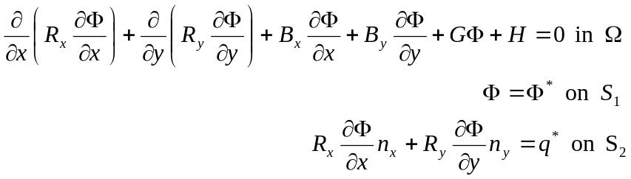 (1)

In which the coefficients 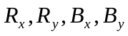, G and H are given as functions of x and y. The two-dimensional domain is denoted by . S is the boundary of the domain and S₁ and S₂ are parts of that boundary and satisfy 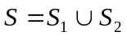. 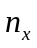 and 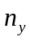 represent the outward normal unit vectors on the boundary.

3.1. Governing Equation for Fluid Flow Analysis

Poisson’s equation is originated from the general governing partial differential equation and it is adequate to describe a large number of applied problems including the flow of ideal fluids problems. The two governing equations for the flow of ideal fluids are

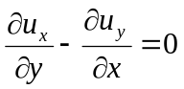 (Irrotational flow) (2)

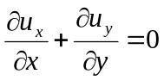 (Incompressible flow) (3)

If we define 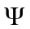 such that it identically satisfies the condition for incompressible flow, then we have

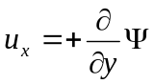 (x component of the velocity) (4)
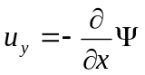 (y component of velocity) (5)
By substituting equations (4) and (5) into equation (2), the stream function of the fluid flow can be written as follows

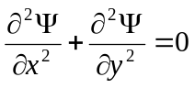 (6)

3.2. Governing Equation for Temperature Flow Analysis

For steady state two-dimensional convection through a constant-property homogenous fluid, the energy equation is given by (Reference 2)

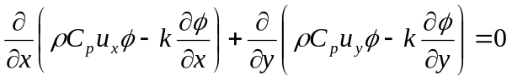 (7)

or in other form

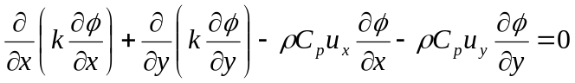 (8)

Where is the temperature, k is the thermal conductivity of the fluid and 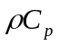is the heat capacity of the fluid. 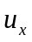 and 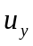 denote the velocity components in x and y directions, respectively. Since the time-dependency is beyond the scope of this paper, the thermal conductivity of the fluid will be assumed to be time independent and take a constant value k = 1.0. Also, the heat capacity is assumed to be equal to 1.0.

- Finite Element Modeling

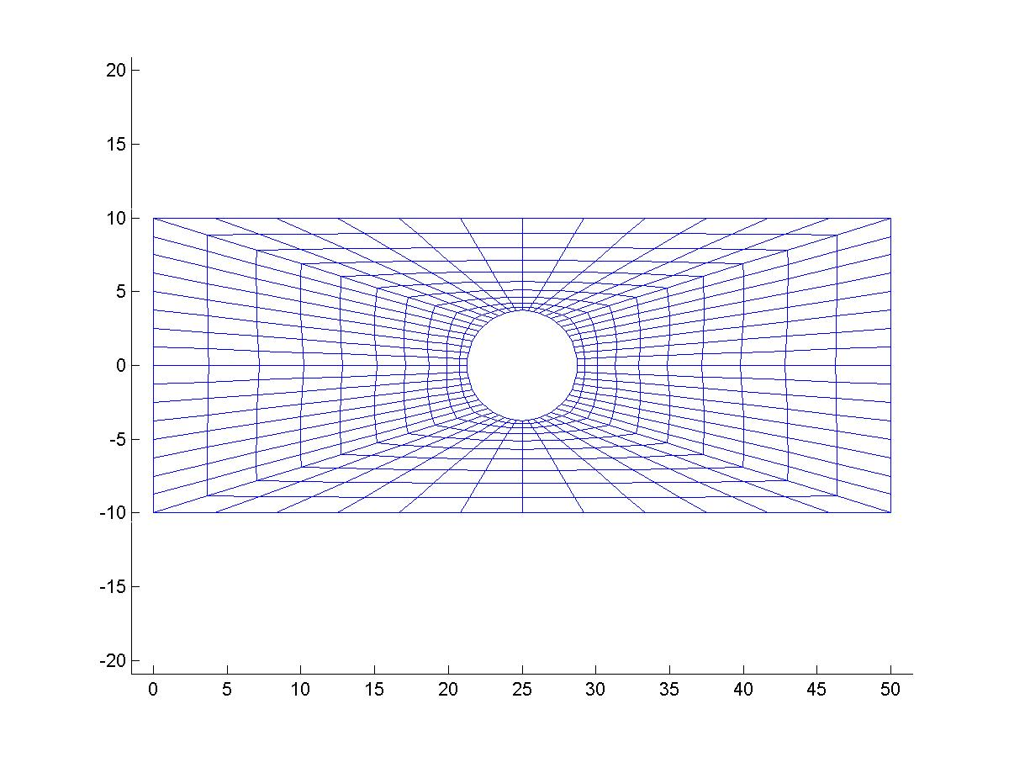
The problem is discretized using a previously developed Matlab code mesh generator “mesh.m” provided in Reference [1]. The input data for the mesh generator are the number of generation loops and some geometric coordinates of specific points on each side of each loop. Also, the number of divisions per each side is required to specify the number of elements per each loop. In the current study, six loops are used to generate the mesh of the domain (Figure 2). Thus, the total used number of elements is 560 elements and that corresponds to a total number of nodes 616. A four-node isoparametric quadrilateral element is used to model the domain to maintain the continuity of the degrees of freedom along the edges of the elements. It should be noted, as shown in Figure 2, that the sizes of the elements decreases with getting closer to the small pipe at the middle to ensure the accuracy of the solution at this area of concentrated stresses. The mesh discretization provided in Figure 2 will be used in both the flow and temperature analyses.
Figure 2 Mesh Discretization of the Domain (560 elements and 616 nodes).
1
2
3
4
5
6

A Matlab user INCLUDE code denoted by NPCODE.m (provided in Reference 1) is included in mesh.m code immediately before the output is saved. The purpose of this code is to assign NPcode values to each node. These values have meaning only to the user and are not used in any of the finite element codes. However, the user can use these numbers in any other supplement code. The NPcode values are often used in the INITIAL.m Matlab user INCLUDE code (will be discussed in later section) that set boundary and initial conditions for a particular finite element analysis. The output files of the mesh generator program “mesh.m” are ASCII files; MESHo, NODES and NP. The MESHo file contains the number of nodes, number of elements, and number of nodes per element, respectively. The NODES file includes three columns and number of rows equal to the total number of nodes. The first two columns contain X and Y coordinates of each node, while that last column contains the NPcode value for each node. Finally, NP file includes the connectivity array between the elements.

A problem encountered with the two-dimensional problem analyses is how to number the nodes such that it minimizes the storage needed for the stiffness matrix. The bandwidth of the stiffness matrix depends on the way the nodes have been numbered. Also, the difference between a good numbering scheme and a poor numbering scheme can result in a very large difference in bandwidth requirements. Since finite element equations are related to each other only through common elements, reduction of the bandwidth needs nodes that are connected by common elements be as close in numerical value as possible. A previously developed bandwidth reduction program developed using Matlab code denoted newnum.m (Provided in Reference 1) is used in the analysis to specify a new numbering scheme that is able to reduce the bandwidth of the stiffness matrix. The ASCII files that are resulted from the mesh.m program are used as input files for the newnum.m program.

The code described in the newnum.m program begins with the specification of one or more nodes as starting nodes. The user specifies these nodes be the first nodes in the new numbering scheme. For example, if five nodes are designated, the line connecting these nodes is referred to as the first wave of nodes (Figure 3). The second wave consists of all nodes that are linked to nodes in the first wave through common elements. The nodes in the second wave are then given the next consecutive numbers in the new order. This process continues until all nodes have been given new numbers. Finally, all elements should have node numbers that differ by no more than the number of nodes in the longest two consecutive waves, and even less. The output of newnum.m program is an ASCII file denoted NWLD, which contains the new numbering scheme that will be used in the finite element analysis.

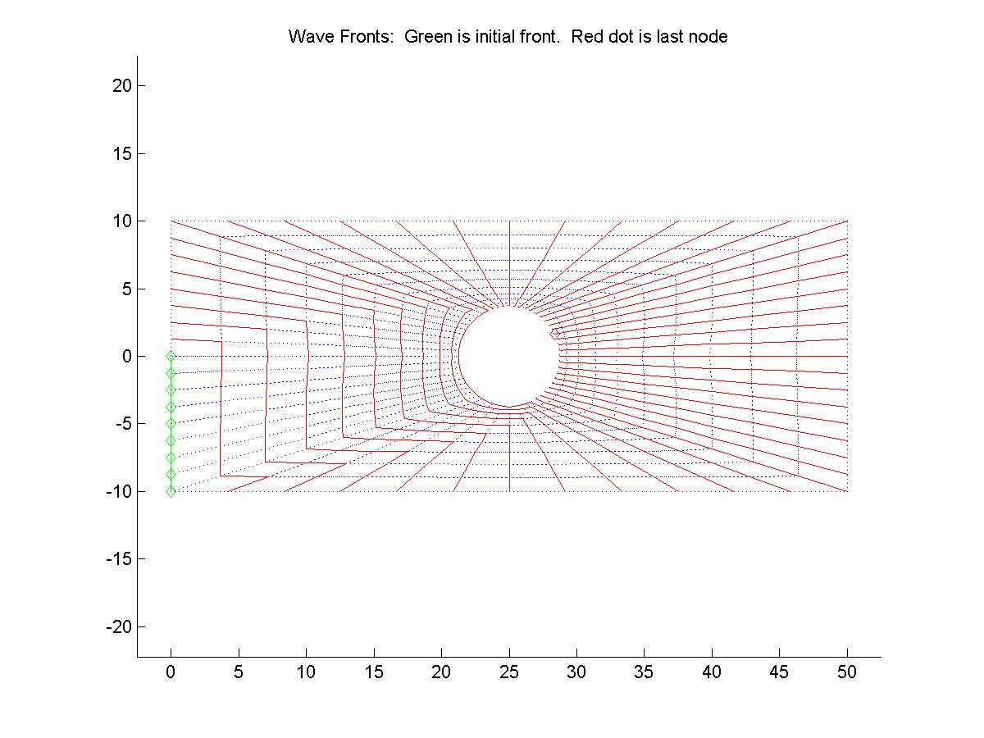
Figure 3 Wave Fronts for New Numbering Scheme (Green is first wave and red dot is last node).

- Flow Analysis

Both fluid flow and temperature flow can be described by the general equation that governs the two-dimensional problems (Equation (1)). However the coefficients of the governing Equation (1) (, G and H) differ from the fluid flow to the temperature flow such that they satisfy the governing equations given in Equations (6) and (8) for fluid flow and temperature flow, respectively. The previously developed Matlab program denoted steady.m is used to conduct the finite element analyses for fluid and temperature flow. The flow chart that describes this program is given in Figure 4 and the source code of the program is enclosed in Appendix I.

  - Fluid Flow Analysis

The fluid flow is characterized by the Poisson’s equation given by Equation (6) and recalled here for convenience

in which the coefficients of the general governing equation (1), , G and H, take the following values; 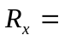1.0, 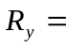 1.0, 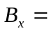 0.0, 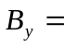0.0, G = 0.0 and H = 0.0. These coefficients are incorporated in the user INCLUDE Matlab program denoted COEF.m, which is called from inside the steady.m program to define these coefficients.

The boundary conditions for the fluid flow analysis are illustrated in Figure 5. The x-component of the velocity at the entrance and at the exit is constant. As such, integrating equation (4) for the x-component of the velocity gives the fluid flow conditions at entrance and at exit as

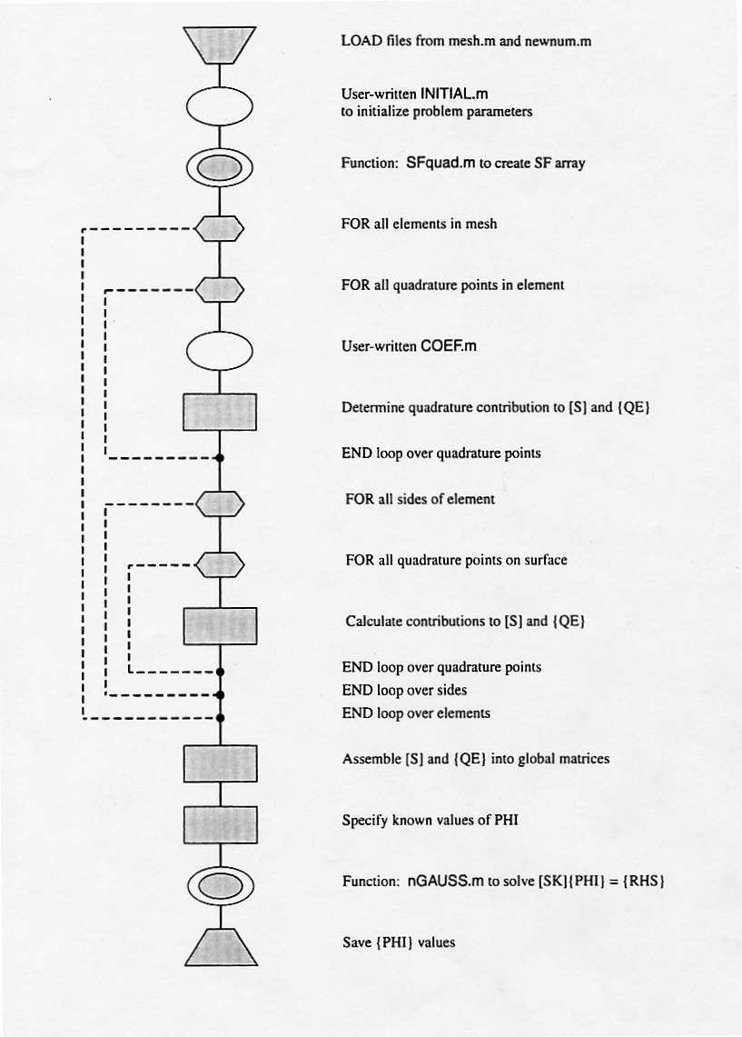
Figure 4 Flow Chart of steady.m Program
Velocity components for Temperature flow case

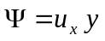 (9)

in which, is constant specific values for the velocity and y is the y-coordinates of the nodes in that boundary. Since, the flow is non-viscous and incompressible, the x-component of the velocity maintains constant at the upper and lower boundaries. Thus, the boundary conditions of fluid flow at upper and lower boundaries can be given by the relations;

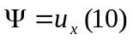 (at upper boundary) (10)

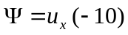 (at lower boundary) (11)

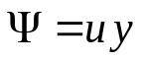
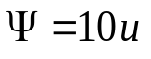
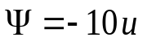
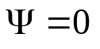
Where the values 10 and –10 are the y-coordinates of the nodes on upper and lower boundaries, respectively. The y-component of the velocity, i.e. 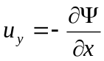 , is constant and equal to zero the at entrance and the exit. Also, to maintain the non-viscosity and incompressibility of the fluid, the fluid flow at the small circular pipe at the middle of the domain is taken equal 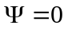. These boundary conditions are specified in the INITIAL.m Matlab program code (enclosed in Appendix II), which is called from inside the steady.m program to define the boundary conditions of the problem. Once the boundary conditions and the coefficients are defined in the steady.m program, the analysis of the fluid flow is determined. Results are obtained for different values of the entrance velocity = 0.0, 0.30, 0.60 and 1.0. Figure 6 shows the flow field of the fluid at the different specified values of the entrance velocity. As illustrated from the results that the flow field is the same for all values of the velocities, however, the absolute values of the flow increases with increasing the entrance velocity. Also, it is noticed that when the velocity = 0.0, the flow field is static and the stream function is constant all over the domain.
20 units
50 units
y
x
Figure 5 Boundary Conditions of the Fluid Flow.
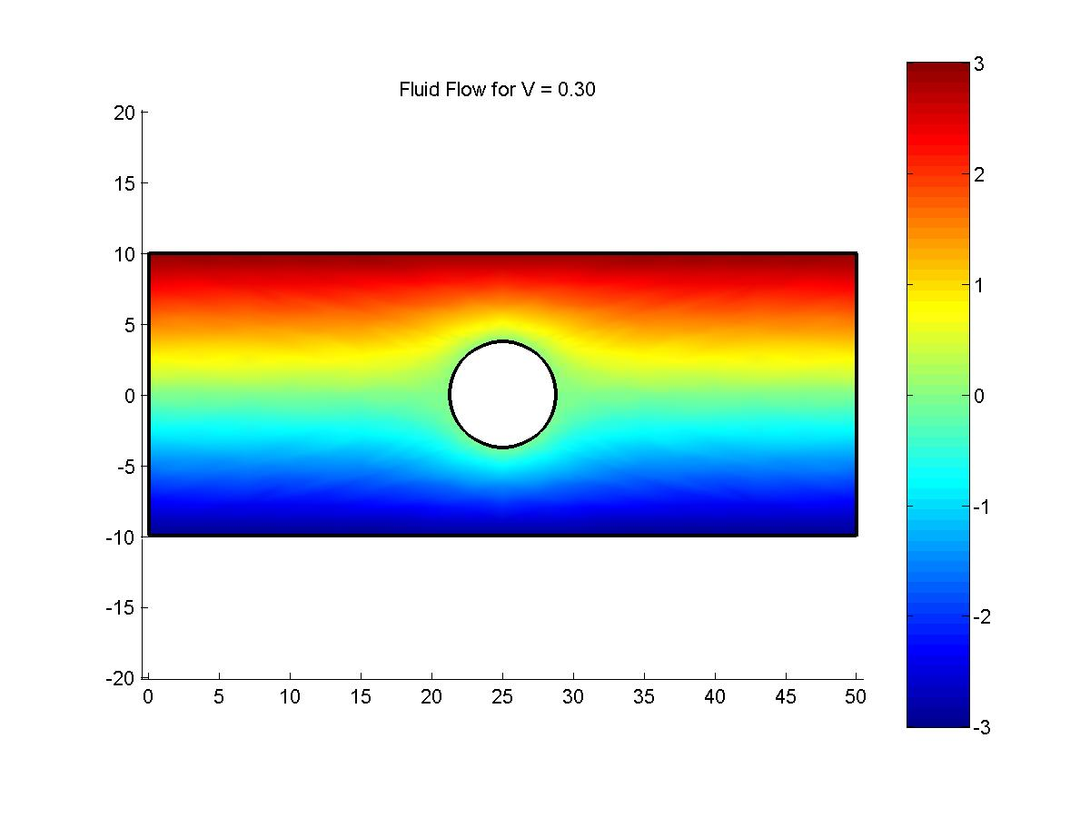
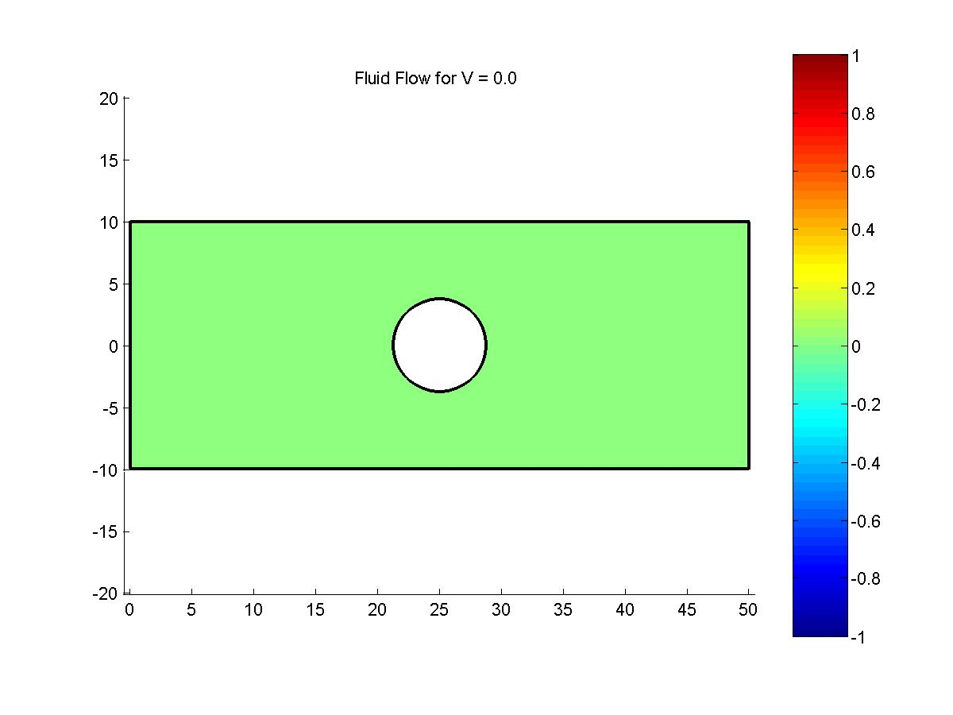
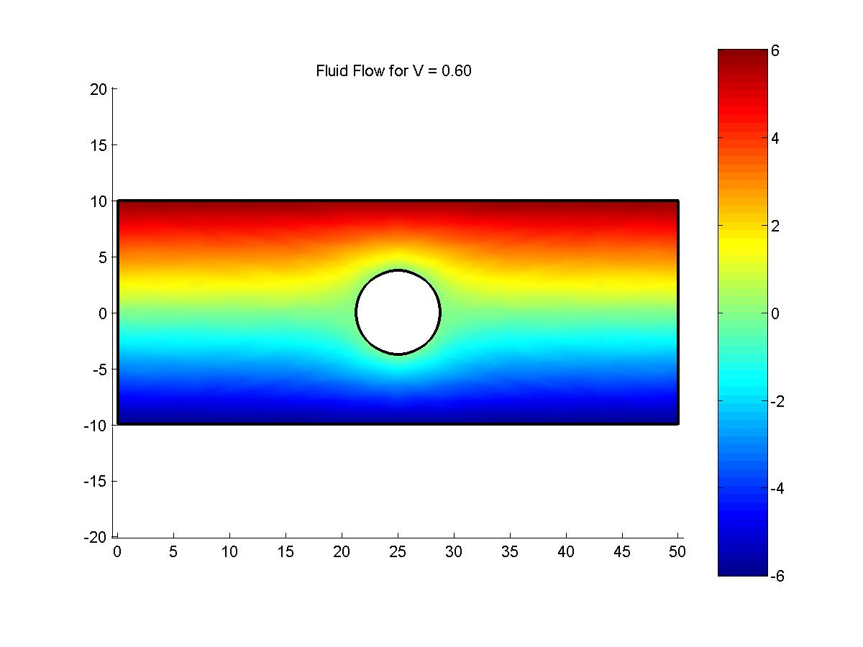
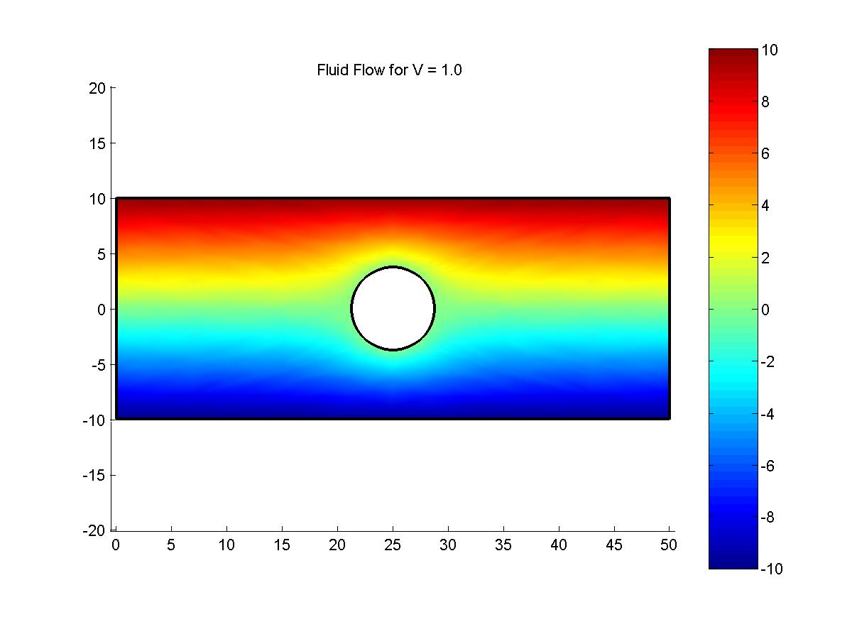
Figure 6 Fluid Flow Field for Different Values of Entrance Velocity.
(a)
(b)
(c)
(d)

  - Temperature Flow Analysis

The temperature flow is characterized by the energy equation given by Equation (8) and recalled here for convenience

in which the coefficients of the general governing equation (1), , G and H, take the following values; 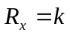, 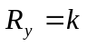, 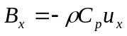 , 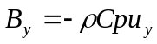, G = 0.0 and H = 0.0. The thermal conductivity and the heat capacity of the fluid are assumed to have unit values. The coefficients 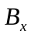 and 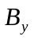are functions of velocity components and , respectively. Recalling that the velocity components and are given by using equations (4) and (5) as derivatives of the fluid flow with respect to x and y, respectively. As such, a small Matlab code is incorporated in the steady.m program at the position shown in the flow chart (Figure 4) just before calling the user’s INCLUDE file COEF.m to calculate the velocity components and . This Matlab code is illustrated as follows;

% -----------------------------------------
% Calculating velocity components
% -----------------------------------------
for K=1:NNPE;
NPK=NP(I,K);
VP060(K,I)=VP06(NPK);
ux1= ux1+DNDY(K)*VP060(K,I);
uy1= uy1-DNDX(K)*VP060(K,I);
end
% ----------------------------------------
in which NNPE is the number of nodes per element, NPK is the global numbering of each node, NP is the array of global numbering of each nodes as function of element number I and local node numbering K. The derivatives of the flow functions with respect to x and y at each node are denoted by DNDY(K) and DNDX(K), respectively. VP06(NPK) is the fluid flow function values, , resulting from fluid flow analysis for entrance velocity equal = 0.6 given for the global numbering of the nodes. VP060(K,I) is the two dimensional array of the fluid flow function given at each local node per each element. Once the velocity components and are calculated, the steady.m program call for the user’s INCLUDE code COEF.m to read the rest of the coefficient as ; 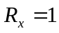, 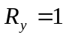, 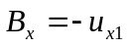 , 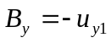, G = 0.0 and H = 0.0.

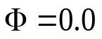
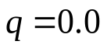
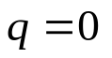
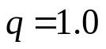
The boundary conditions for the temperature flow analysis are illustrated in Figure 7. The small pipe at the middle is assumed to produce q units of energy per surface area of the pipe per unit time. The energy q is considered equal to unity at the small pipe and equal to zero at exit, lower boundary and upper boundary. The temperature flow is considered equal to zero at entrance. These boundary conditions are employed in the INITIAL.m Matlab program code (enclosed in Appendix III), which is called from inside the steady.m program to define the boundary conditions of the problem. Once the boundary conditions and the coefficients are defined in the steady.m program, the analysis of the temperature flow is ascertained.
20 units
50 units
y
x
Figure 7 Boundary Conditions of the Temperature Flow.

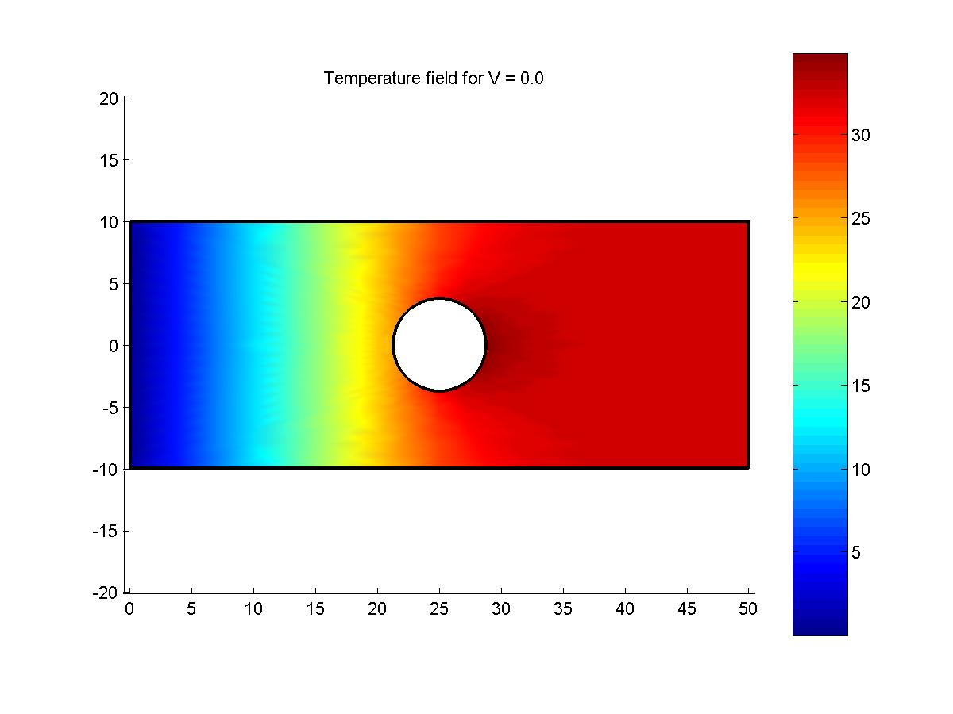
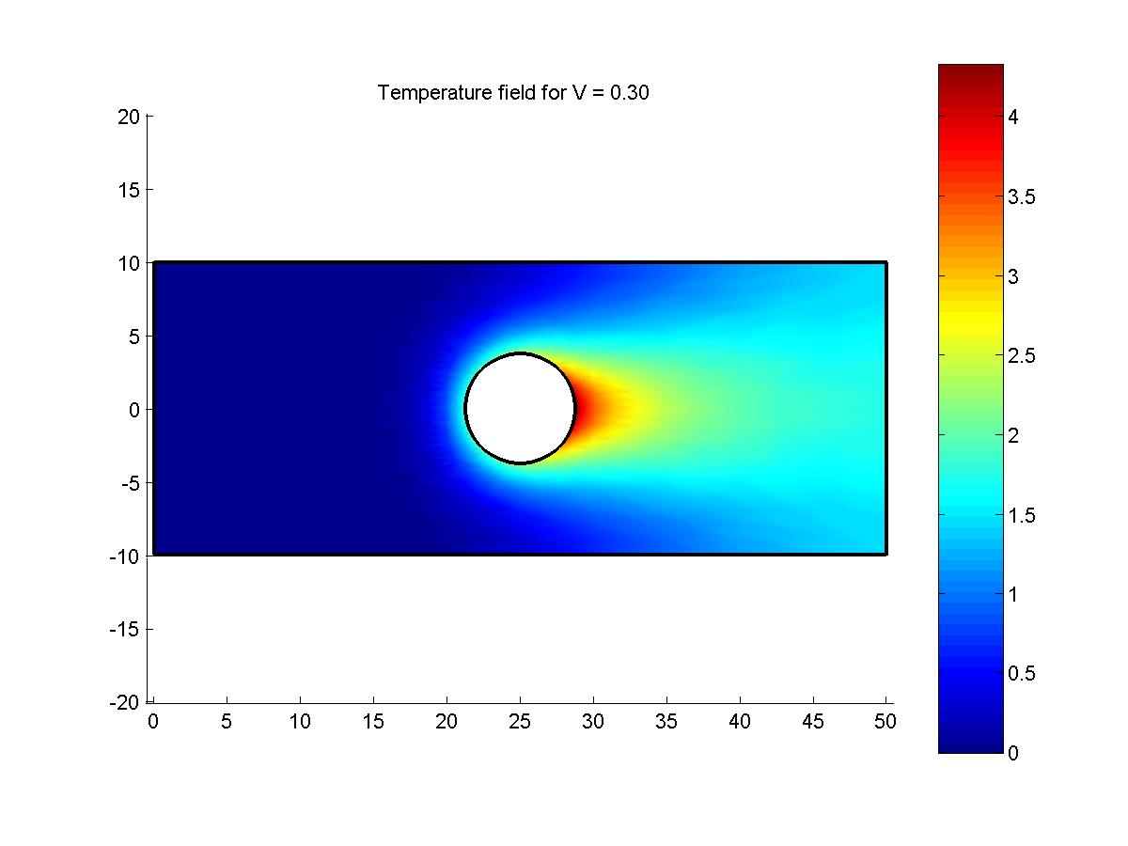
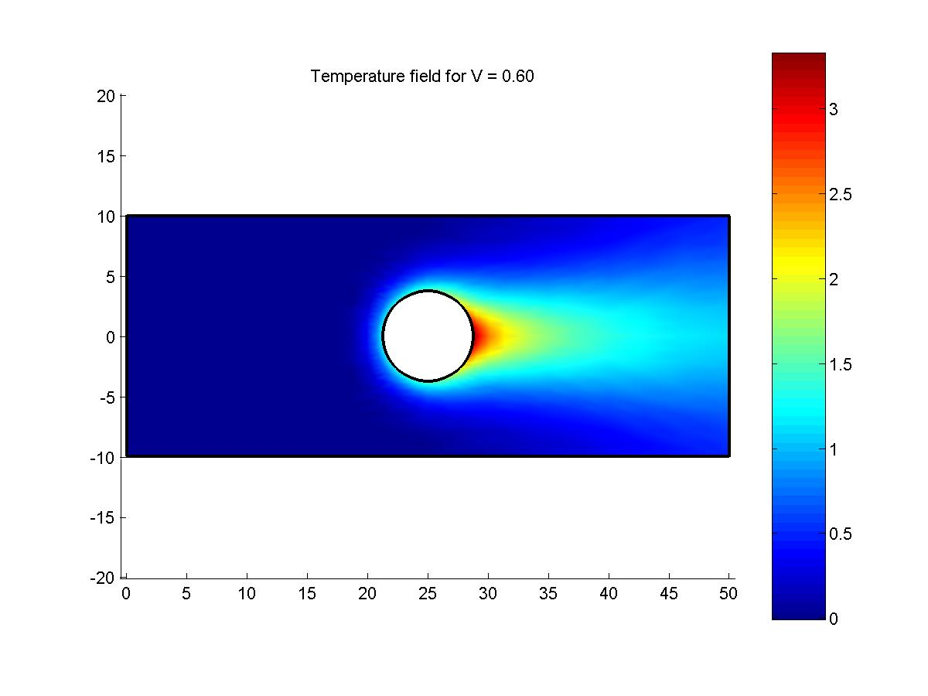
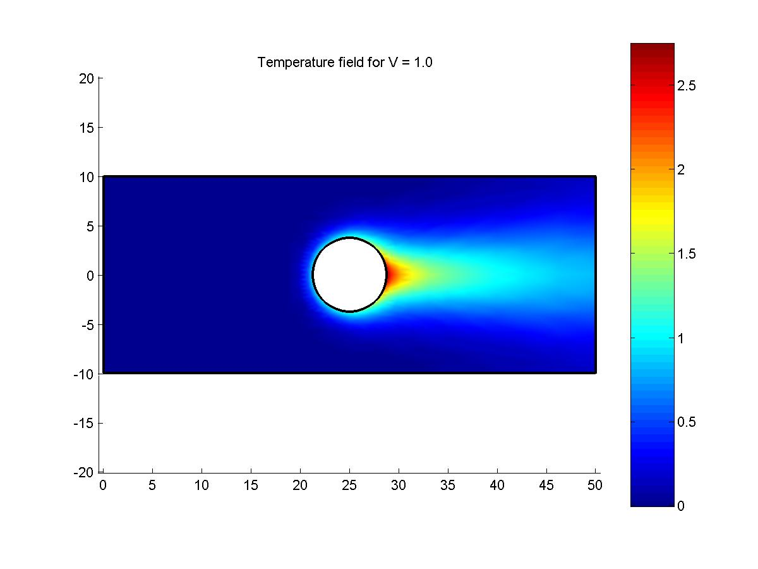
Results are obtained for different values of the entrance velocity = 0.0, 0.30, 0.60 and 1.0. Figure 8 shows the flow field of the temperature at the different specified values of the entrance velocity. It is noticed from the results that there is a steep decrease in the temperature field with increasing the entrance velocity. This coincides with the fact that heat transferred by convection is greater than heat transferred by conduction. Also, Figure 8 illustrates that the rate of heat transferred through the domain is increasing by increasing the velocity, which results in decrease of temperature near the heat source in the middle of the domain.
Figure 8 Temperature Flow Field for Different Values of Entrance Velocity
(a)
(b)
(c)
(d)

- Conclusions

In this study, a two-dimensional non-viscous incompressible steady flow problem is analysed using the finite element method through solving partial differential equations of the fluid flow. The fluid flow is expressed by partial differential equation (Poisson’s equation). While, heat transfer is analyzed using the energy equation. The flow field of that fluid is then used to solve the partial differential equations of temperature flow. The domain of the problem is discretized to a large number of four-node isoparametric elements to assure the accuracy of the solution. The influence of the presence of heat source inside the domain on the temperature flow field is also investigated. Analyses are done by studying both flow field and temperature field for various values of entrance velocity. Results showed that both fluid flow and temperature flow are influenced considerably by changing entrance velocity. Also, there is an obvious effect on the temperature flow field due the presence of an energy source in the middle of the domain.

References:

[1] Thompson, Erik G., Introduction to the Finite Element Method: Theory Programming and Applications, John Wiley & Sons Inc, 2004

[2] Bejan A, Convection Heat transfer, John Wiley and Sons Inc, 1984

[3] Winget J. M, Hughes T.J.R., Solution algorithms for nonlinear transient heat conduction analysis employing element by-element iterative strategies, Computer Methods in Applied Mechanics and Engineering, 1985; 52:711–815.

[4] Johan Z, Hughes T.J.R, Shakib F., A globally convergent matrix-free algorithm for implicit time-marching schemes arising in Finite element analysis in Fluids, Computer Methods in Applied Mechanics and Engineering 1991; 87:281–304.

[5] Jacob BP, Ebecken NFF., Adaptive time integration of nonlinear structural dynamic problems. European Journal of Mechanics and Solids 1993; 12(2):277–298.

Appendix I

(steady.m Matlab Code)

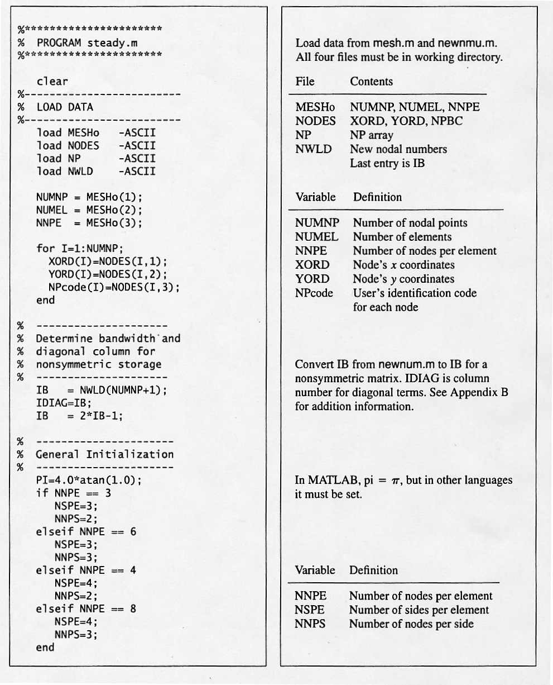

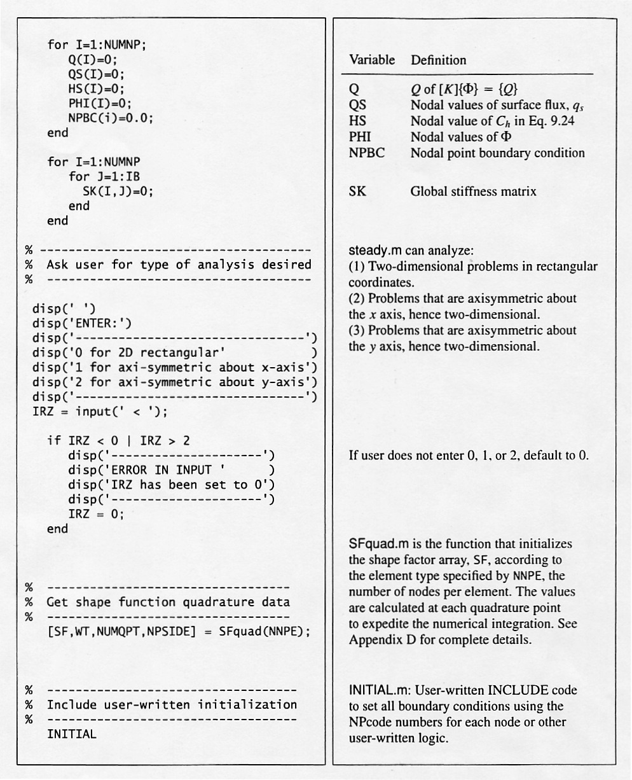

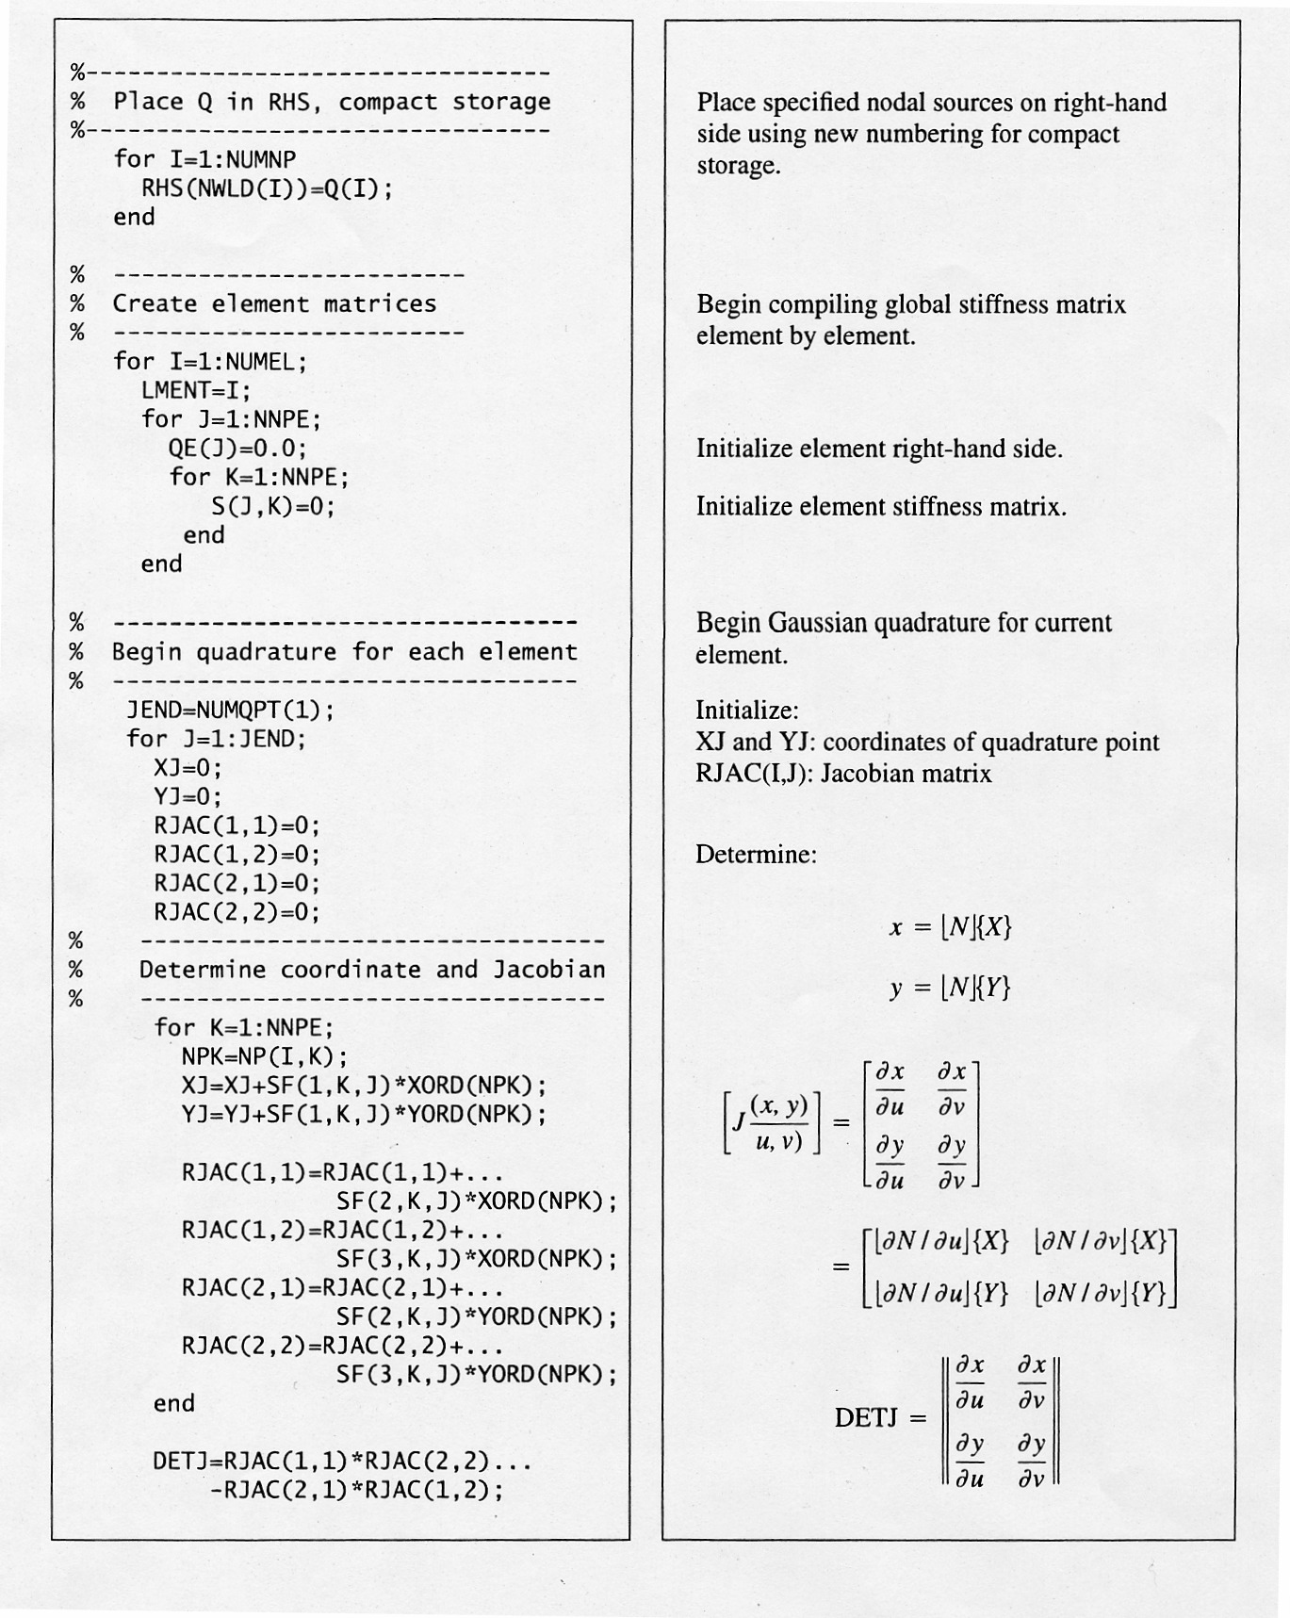

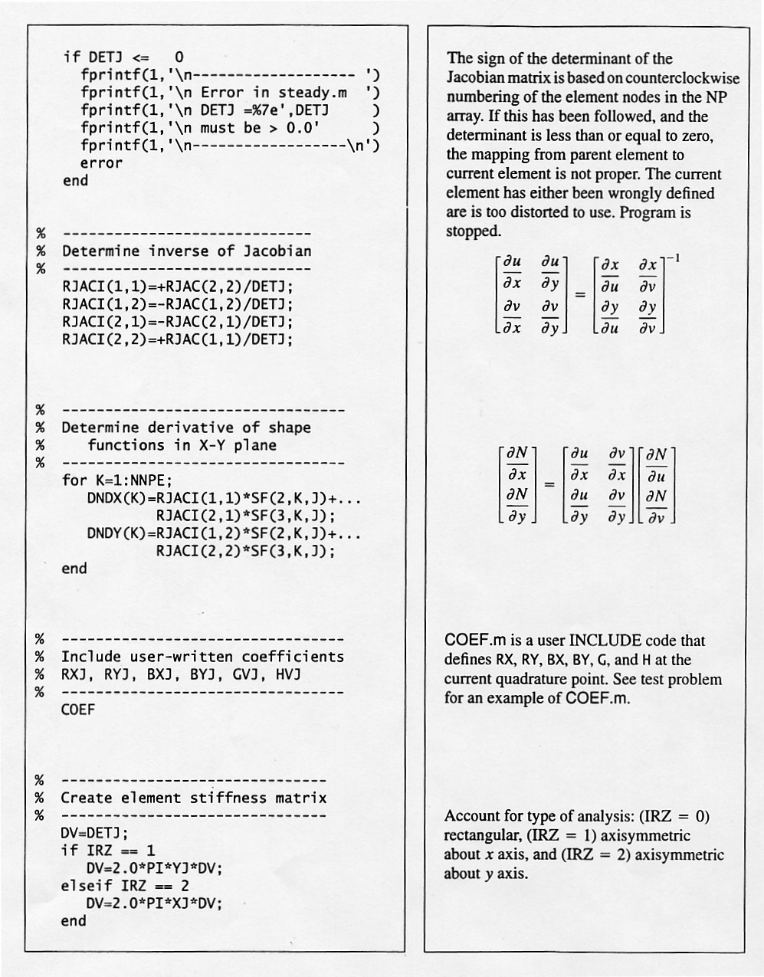

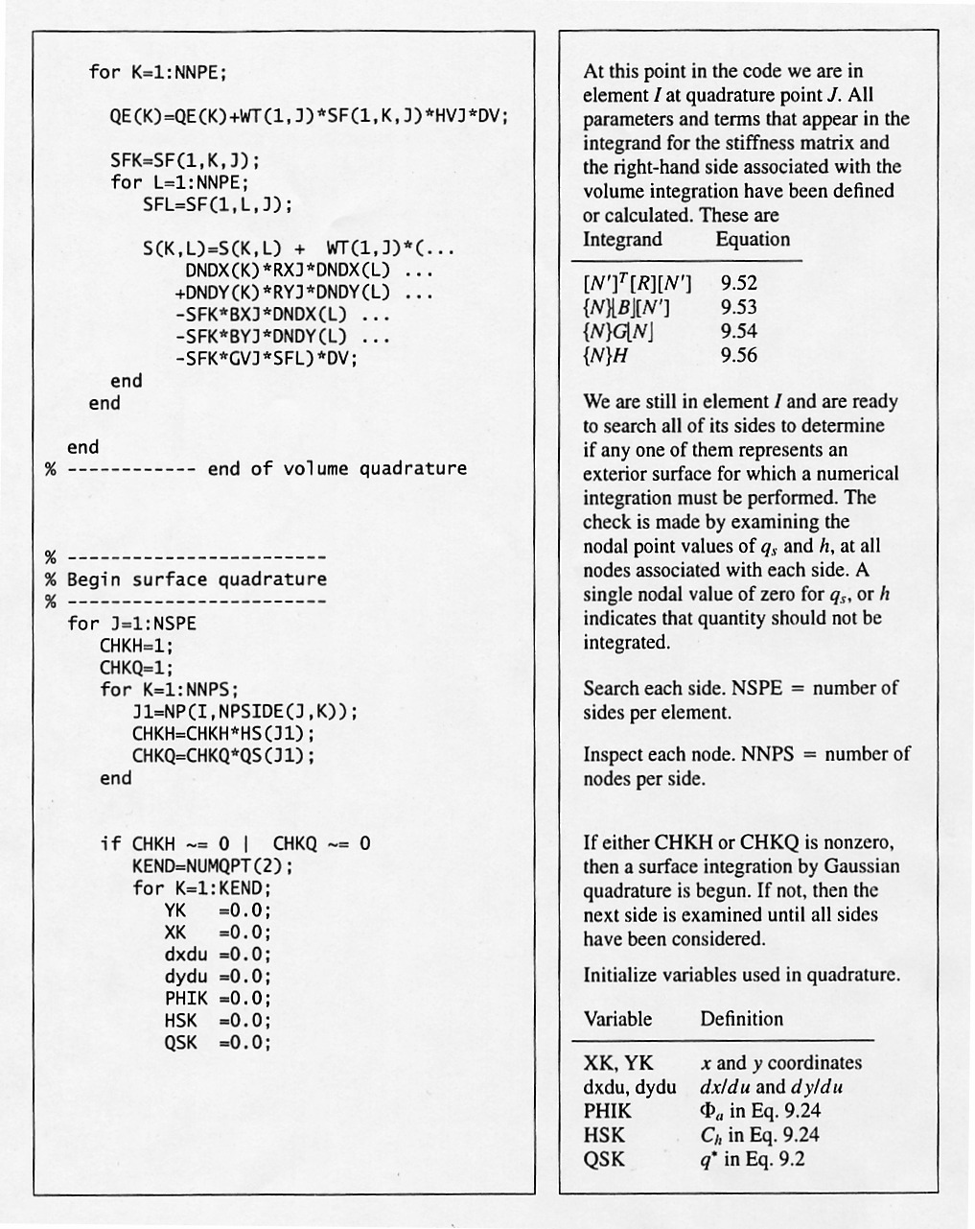

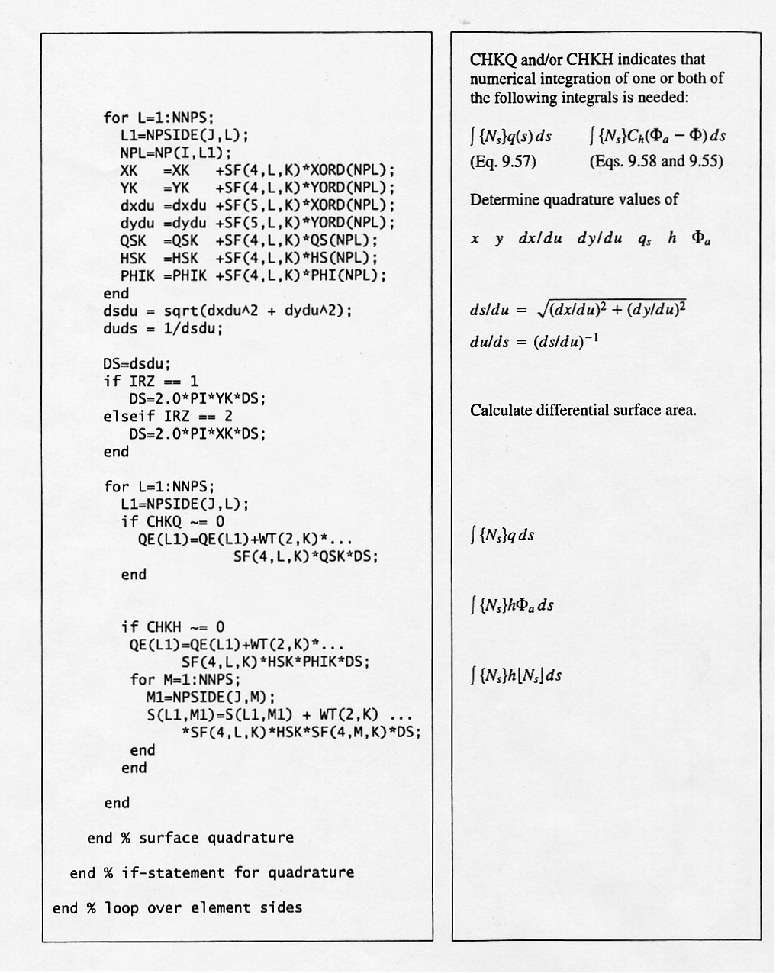

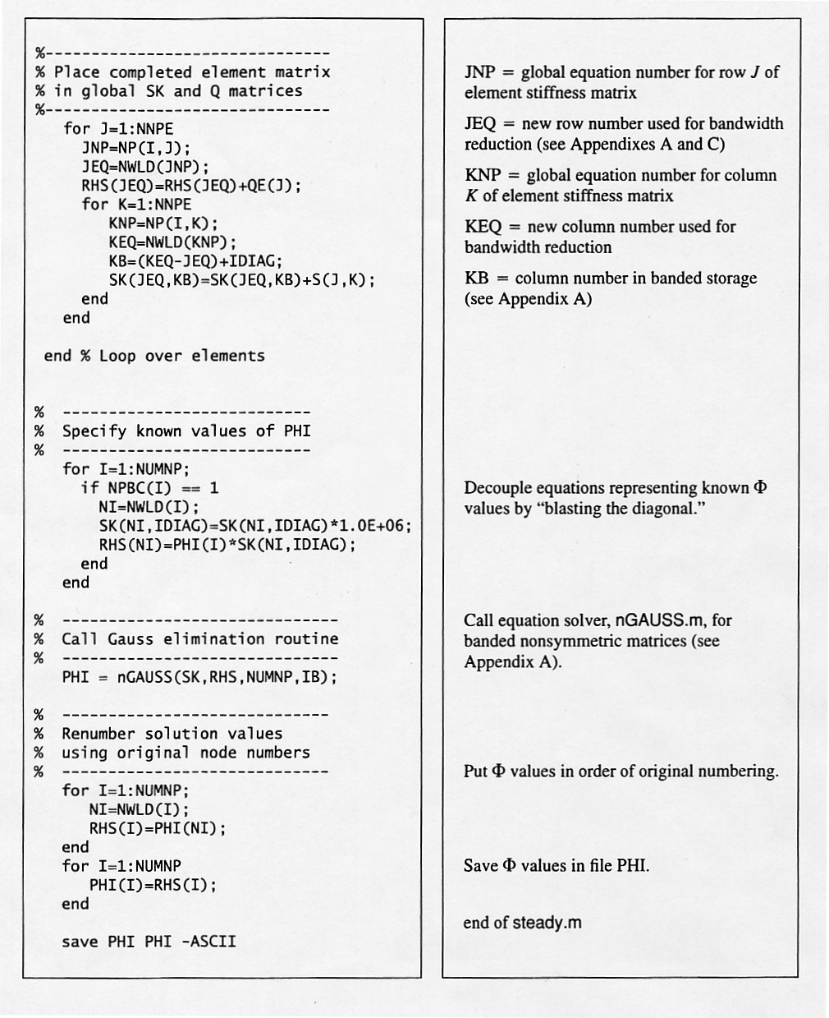

Appendix II

Fluid Flow Analysis
- INITIAL.m Matlab code

%-------------------------------
% INITIAL.m
%
% Set problem parameters.
%-------------------------------
for Ix=1:NUMNP
if NPcode(Ix) == 1 %Left Boundary
NPBC(Ix)=1;
QS(Ix)=0;
HS(Ix)=0;
PHI(Ix) = YORD(Ix)*0.6; % 0.6 is the velocity
Q(Ix)=0;
elseif NPcode(Ix)==2 % Bottom Boundary
NPBC(Ix)=1;
QS(Ix)=0;
HS(Ix)=0;
PHI(Ix) = -10*0.6; % -10 is Y-Coord at bottom & 0.6 is the velocity
Q(Ix)=0;
elseif NPcode(Ix)==3 % Right Boundary
NPBC(Ix)=1;
QS(Ix)=0;
HS(Ix)=0;
PHI(Ix) = YORD(Ix)*0.6; % 0.6 is the velocity
Q(Ix)=0;
elseif NPcode(Ix)==4 %Top Boundary
NPBC(Ix)=1;
QS(Ix)=0;
HS(Ix)=0;
PHI(Ix) = 10*0.6; % 10 is Y-Coord at top & 0.6 is the velocity
Q(Ix)=0;
elseif NPcode(Ix)==5 %Circular Pipe
NPBC(Ix)=1;
QS(Ix)=0;
HS(Ix)=0;
PHI(Ix) = 0;
Q(Ix)=0;
end
end

%---------------------------------------

- COEF.m Matlab code

%-------------------------------
% COEF.m
%
% Set Equation Coefficients.
%-------------------------------

RXJ = 1.0;
RYJ = 1.0;

BXJ=0;
BYJ=0;

GVJ = 0;
HVJ = 0;

%--------------------------------------

Appendix III

Temperature Flow Analysis
- INITIAL.m Matlab code

%-------------------------------
% INITIAL.m
%
% Set problem parameters.
%-------------------------------
for Ix=1:NUMNP
if NPcode(Ix) == 1 %Left Boundary
NPBC(Ix)=1;
QS(Ix)=0;
HS(Ix)=0;
PHI(Ix) = 0;
Q(Ix)=0;
elseif NPcode(Ix)==2 % Bottom Boundary
NPBC(Ix)=0;
QS(Ix)=0;
HS(Ix)=0;
PHI(Ix) = 0;
Q(Ix)=0;
elseif NPcode(Ix)==3 % Right Boundary
NPBC(Ix)=0;
QS(Ix)=0;
HS(Ix)=0;
PHI(Ix) = 0;
Q(Ix)=0;
elseif NPcode(Ix)==4 %Top Boundary
NPBC(Ix)=0;
QS(Ix)=0;
HS(Ix)=0;
PHI(Ix) = 0;
Q(Ix)=0;
elseif NPcode(Ix)==5 %Circular Pipe
NPBC(Ix)=0;
QS(Ix)=1;
HS(Ix)=0;
PHI(Ix)=0;
Q(Ix)=0;
end
end

%---------------------------------------
- COEF.m Matlab code

%-------------------------------
% COEF.m
%
% Set Equation Coefficients.
%-------------------------------

RXJ = 1.0;
RYJ = 1.0;

BXJ=-ux1;
BYJ=-uy1;

GVJ = 0;
HVJ = 0;

%-------------------------------

